Name: V.Sai Saketh Roll No:2520090055
Skill week-3
Step 1 – Create Database, Tables and Insert Class Data
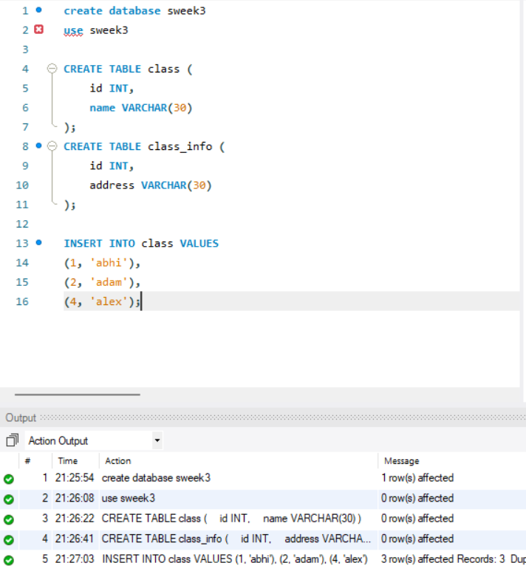

Step 2 – CROSS JOIN
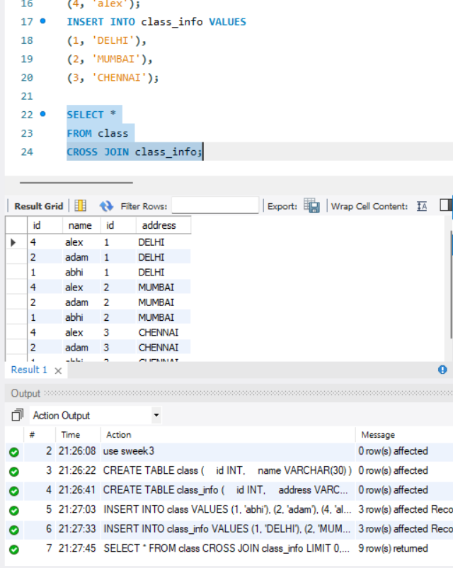

Step 3 – INNER JOIN
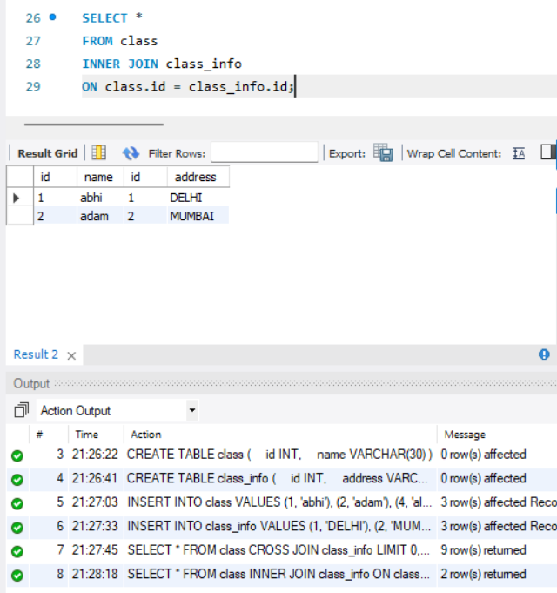

Step 4 – INNER JOIN with Selected Columns
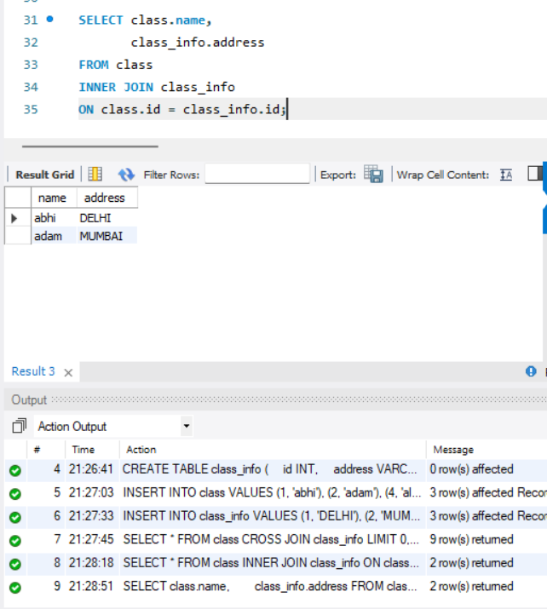

Step 5 – NATURAL JOIN
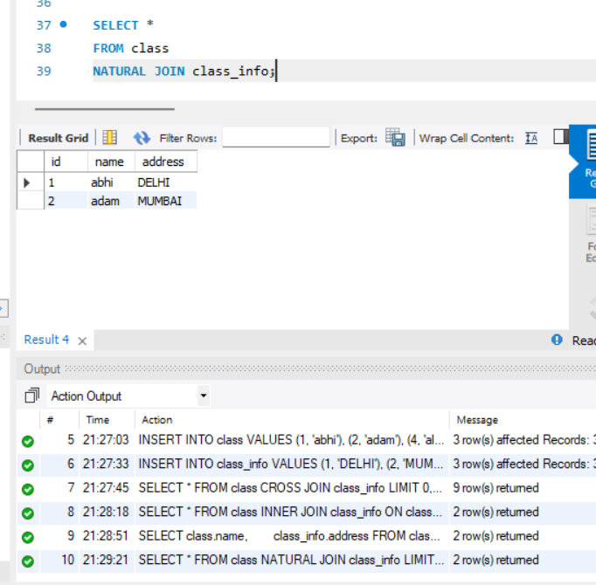

Step 6 – LEFT OUTER JOIN
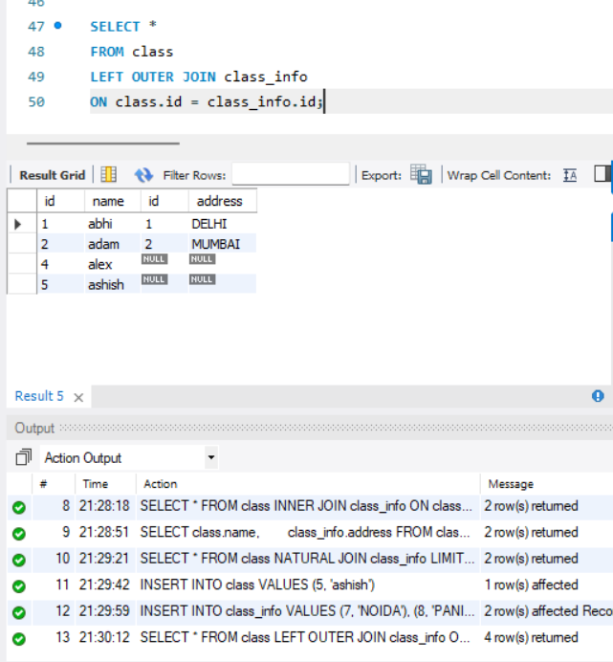

Step 7 – Find Unmatched Rows from the Left Table
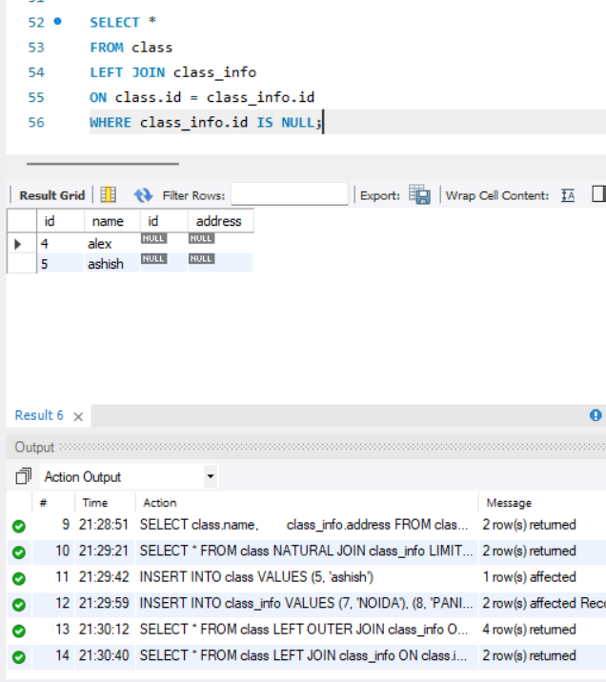

Step 8 – RIGHT OUTER JOIN
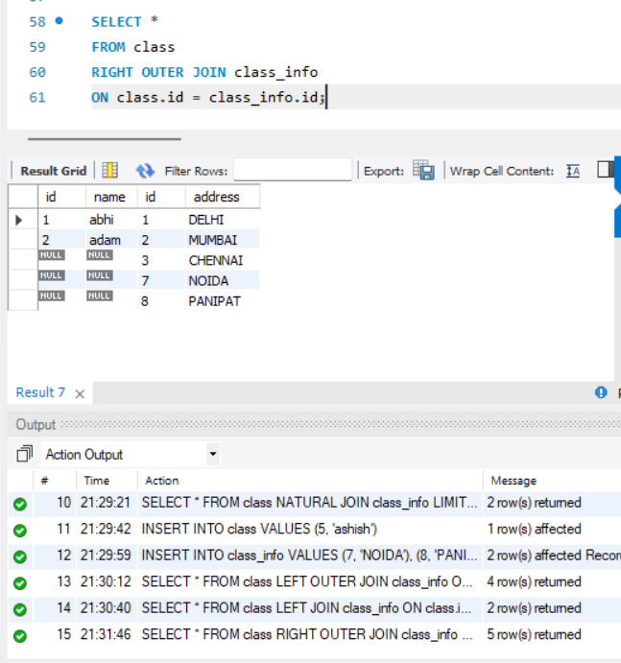

Step 9 – Find Unmatched Rows from the Right Table
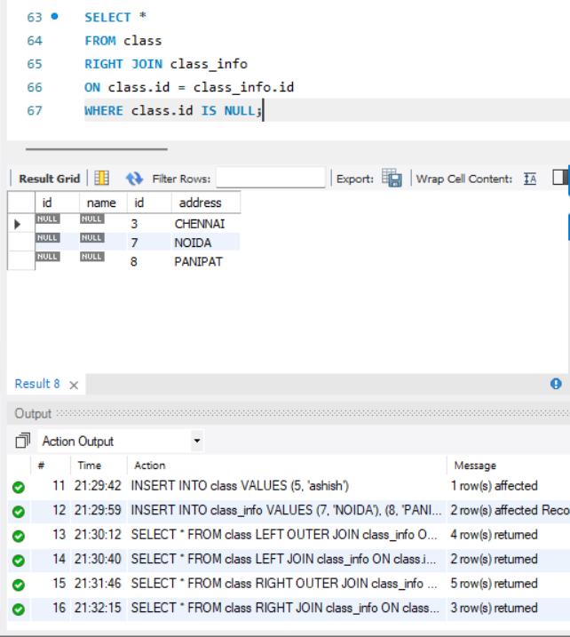

Step 10 – Simulate FULL OUTER JOIN
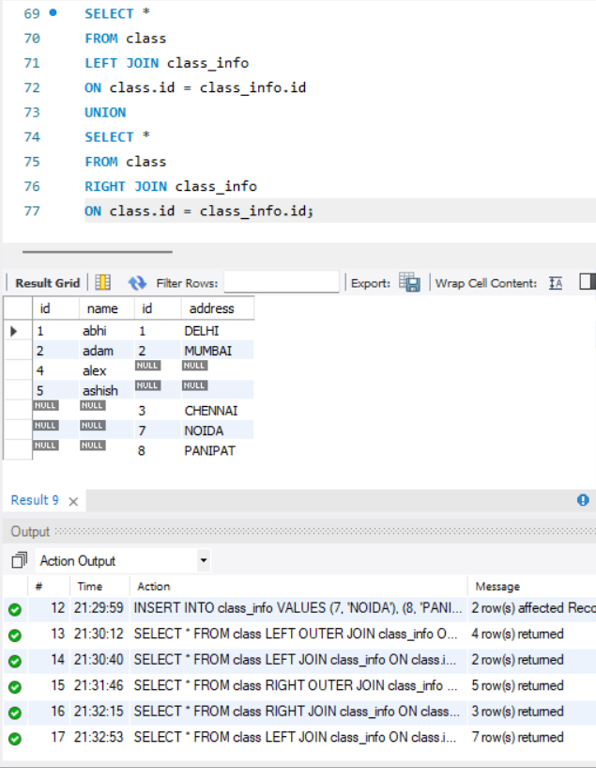

Step 11 – FULL OUTER JOIN for Unmatched Rows
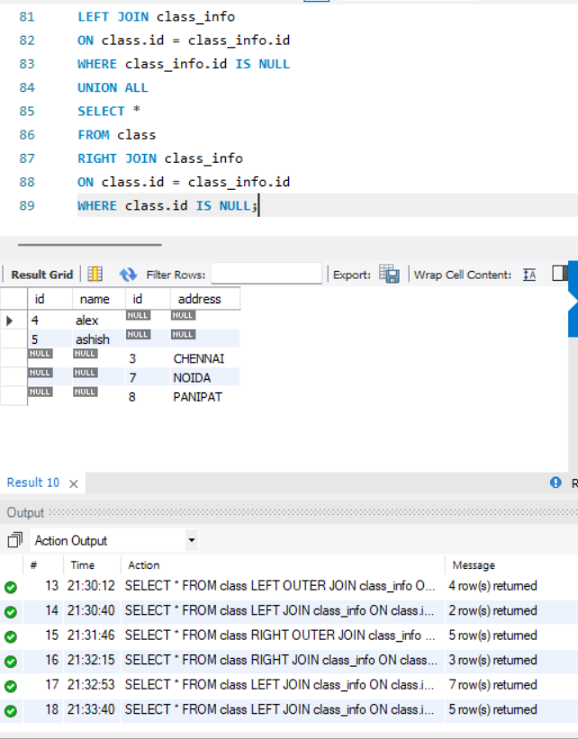

Step 12 – UNION of Two Tables
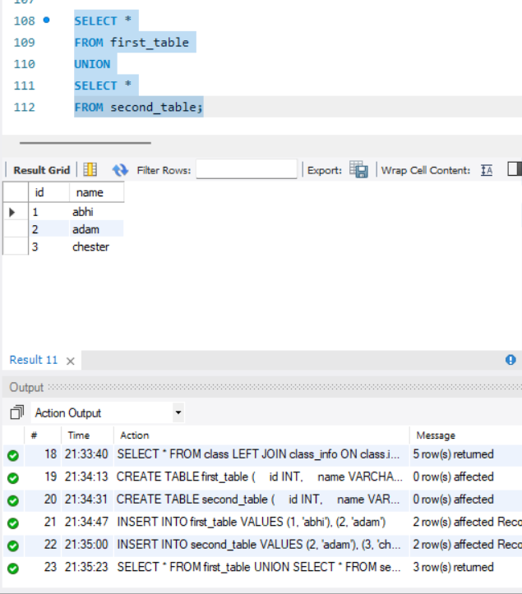

Step 13 – UNION on a Single Column
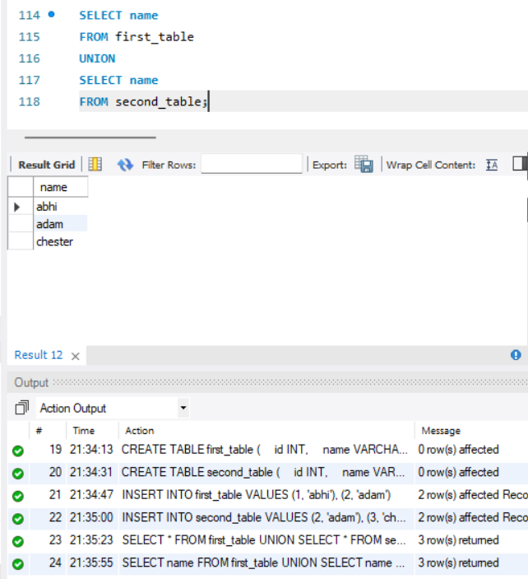

Step 14 – UNION ALL
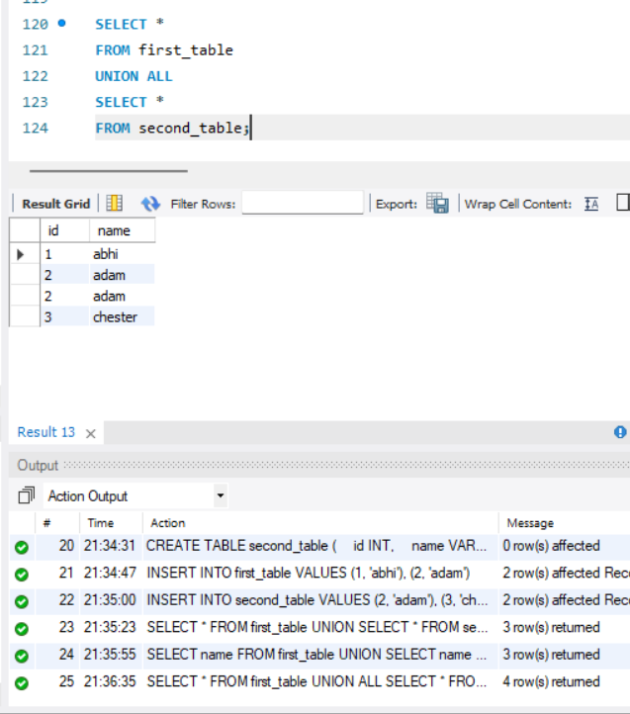

Step 15 – COUNT with UNION ALL
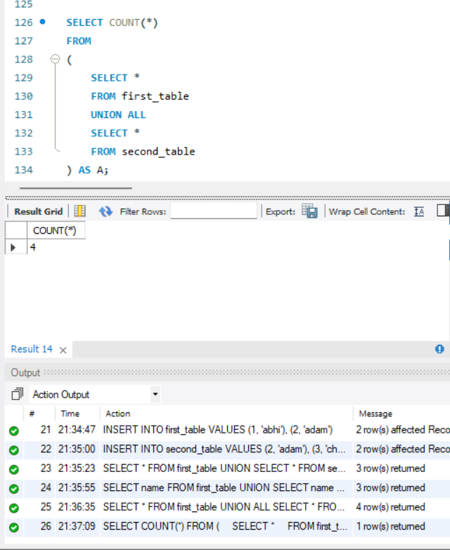

Step 16 – INNER JOIN Using Table Aliases
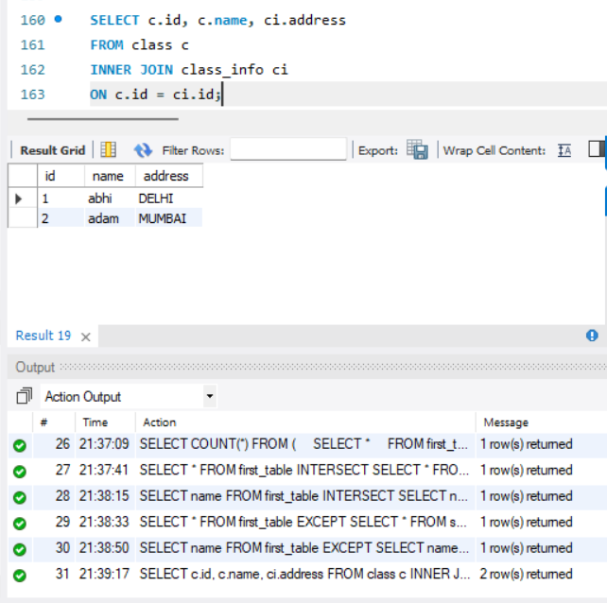

Step 17 – CASE Expression with LEFT JOIN
